

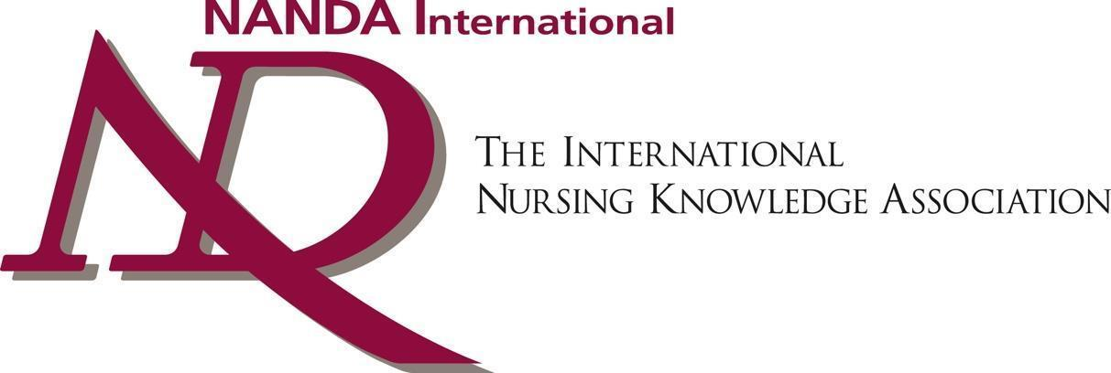

Certificate of Appreciation

This certificate is awarded to

*Vianella Agostinelli*

# in appreciation of the outstanding service rendered as Coordinator of NANDA-I Network Group: Italy for 2022

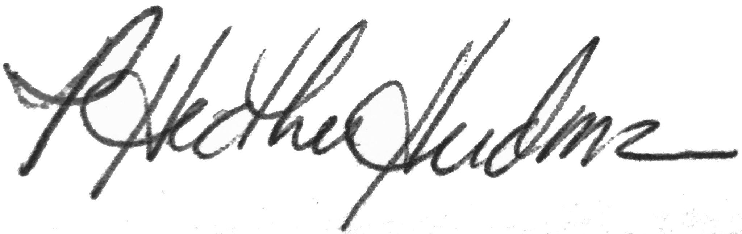

# 

Carme Espinosa i Fresnedo, T. Heather Herdman

MSc, RN, FNI RN, PhD, FNI, FAAN

President Chief Executive Officer